

SIGNIA  
A Real Time Sign Language Recognition System



Team – **Revelion**

Mikhail

209303236

CCE – 2nd year, 4th sem.  
Manipal University Jaipur (MUJ)

Jaipur, RJ

maroof.209303236@muj.manipal.edu

Priyasha Singh

209302050  
IT – 2nd year, 4th sem.  
Manipal University Jaipur (MUJ)  
Jaipur, RJ

priyashasingh2002@gmail.com

Vibhor Sharma  
219310089

AI/ML -- 1st year, 2nd sem.  
Manipal University Jaipur (MUJ)

Jaipur, RJ

vibhor.219310089@muj@manipal.edu

Vivan Jaiswal

219301241

CSE -- 1st year, 2nd sem.

Manipal University Jaipur (MUJ)

Jaipur, RJ  
vivan.219301241@muj.manipal.edu

**Abstract**

Our project focuses on the problem of recognizing in real time the sign language (SL) used by communities of deaf and/or dumb people.   
The problem is addressed by experimenting with different segmentation approaches and unsupervised learning algorithms to create an accurate sign language recognition model.  
  
To more easily approach the problem and obtain reasonable results, we experimented with a few different classes/letters in our self-made dataset instead of all 26 possible letters.   
We collected a few (RGB?) images using our computer webcams.   
We planned to input approx. half of the data into an autoencoder to extract features while using (approximately) the other half for testing purposes.   
  
We’re optimistic we could achieve a decent classification accuracy on a randomly selected set of test data using the trained model we create.  
  
In addition to the work we’ve begun doing with static images, we might also create a live demo version of the project to classify signed hand gestures from any person.   
  
Our main goal is to show that a good performance can be achieved without using any special hardware equipment or complicated approaches resulting in a product/system that can be implemented and easily adopted in real life.

1. **Introduction**

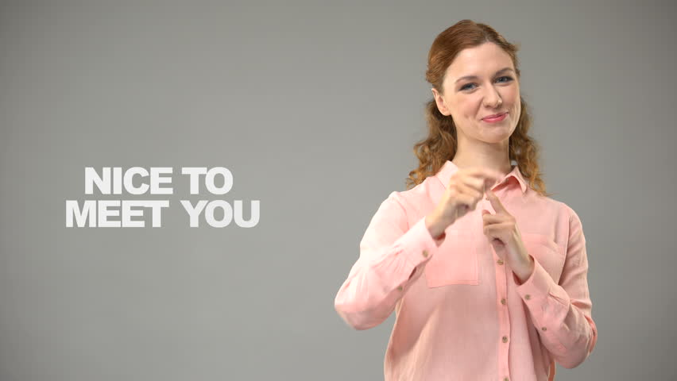

The goal of our work is to make possible the communication between deaf people and the rest of the world in daily life. It may eventually be of some aid to the blind (& other differently abled individuals) as well.   
It is a well-known fact that sign language is known and used in daily communication by deaf people (among others), and persons in frequent contact with them.

 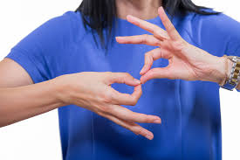

Like any other language SLs have their own grammars and vocabularies but use visual modality for exchanging information. People with hearing disabilities are unable to communicate with other people without a translator. And so more often than not their communication is mostly limited to their family members or familiars in similar circumstances.



For this reason, the implementation of a system that recognizes sign language & helps its speakers communicate with others fluidly in their daily lives (in public spaces, banks, schools, universities, marketplaces etc.) & online 🡪 video/text chat, social media sites etc. would bridge the gap that still separates the hearing-impaired, deaf, dumb, blind, (possibly others) population from the rest of human society.

Further push & help comes in the form of the growing public awareness, approval/demand and increasing focus on & funding for such projects across all levels internationally.  
Research tackling such issues has been long ongoing & with the current (2010s onwards) advancements in technology, engineering & computer science it shows more promise than ever before.

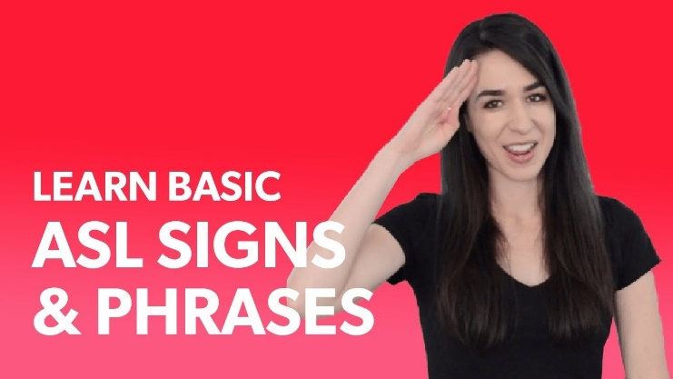

A variety of solutions already exist but none with sufficient potential for real-time, large-scale implementation & use.   
The reality is not many (possibly any) easy-to-setup & use, commercially viable products/systems currently exist on the market.  
  
Note 🡪 ***Since human gestures are perceived through vision, it is a subject of great interest for computer vision researchers.***

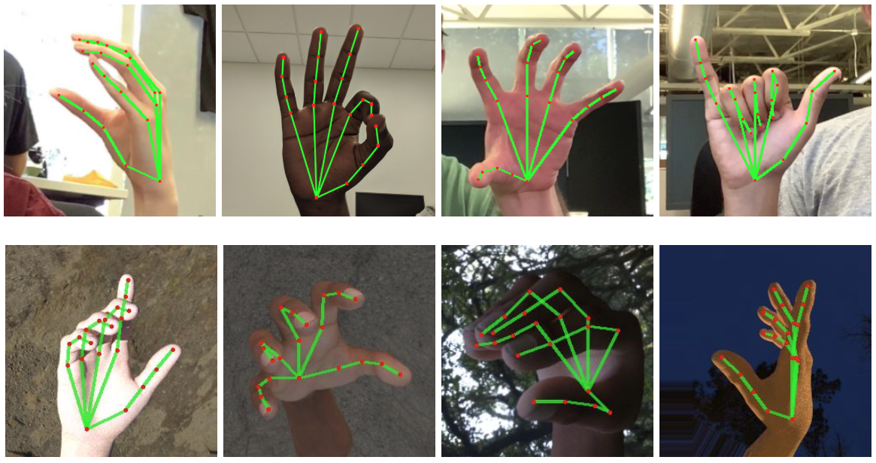

1. **Literature Review**
   1. **Image Processing**

Image processing is a method to perform some operations on an image, in order to get an enhanced image or to extract some useful information from it. It is a type of signal processing in which an image is the input, and the output may be an image or characteristics/features associated with that image. Image processing is a rapidly growing technology.  
  
Image processing involves:  
  
• Importing the image via image acquisition tools.  
• Analysing and manipulating the image.  
• Gaining output in which the result may be am altered image or a report based on image analysis.  
  
There are two types of methods used for image processing 🡪 analogue and digital image processing.  
  
Analogue image processing can be used for hard copies like printouts and physical photographs. Image analysts use various fundamentals of interpretation while using these visual techniques.   
  
Digital image processing techniques help in manipulation of digital images using computers.   
  
The three general phases that all types of data have to undergo in case of digital image processing techniques being used are:  
  
pre-processing, enhancement, and display, information extraction.

* 1. **Sign Language/s (SL)**

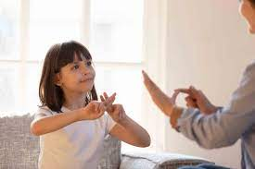

It is a language that includes gestures made with the hands and other body parts, including facial expressions and postures of the body. It used primarily by people who are deaf and dumb. There are many different sign languages as, British, Indian and American sign languages. British sign language (BSL) is not easily intelligible to users of American sign Language (ASL) and vice-versa.  
  
As mentioned earlier, a functioning signing recognition system could provide a chance for fluid communication with non-signing people without the necessity for a translator.  
   
American Sign Language (ASL) is a complete, natural language that has the same linguistic properties as spoken languages, with grammar that differs from English. ASL is expressed by movements of the hands and face. It is the primary language of many North Americans who are deaf and hard of hearing and is used by many hearing people as well.  
  
So, we chose ASL as our only sign language for this project.

**2.3 OpenCV**OpenCV (Open Source Computer Vision Library) is an open source computer vision and machine learning software library. OpenCV was built to provide a common infrastructure for computer vision applications and to accelerate the use of machine perception in the commercial products. Being a BSD-licensed product, OpenCV makes it easy for businesses to utilize and modify the code.

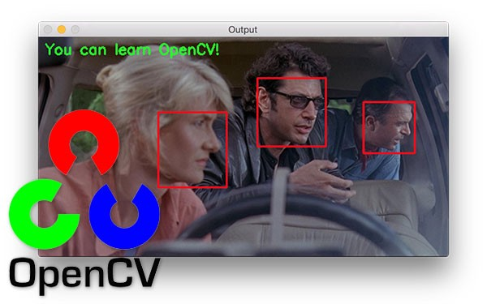

The library has more than 2500 optimized algorithms, which includes a comprehensive set of both classic and state-of-the-art computer vision and machine learning algorithms. These algorithms can be used to detect and recognize faces, identify objects, classify human actions in videos, track camera movements, track moving objects, extract 3D models of objects, produce 3D point clouds from stereo cameras, stitch images together to produce a high resolution image of an entire scene, find similar images from an image database, remove red eyes from images taken using flash, follow eye movements, recognize scenery and establish markers to overlay it with augmented reality, etc. OpenCV has more than 47 thousand people of user community and estimated number of downloads exceeding 18 million. The library is used extensively in companies, research groups and by governmental bodies.

Along with well-established companies like Google, Yahoo, Microsoft, Intel, IBM, Sony, Honda, Toyota that employ the library, there are many startups such as Applied Minds, VideoSurf, and Zeitera, that make extensive use of OpenCV. OpenCV’s deployed uses span the range from stitching streetview images together, detecting intrusions in surveillance video in Israel, monitoring mine equipment in China, helping robots navigate and pick up objects at Willow Garage, detection of swimming pool drowning accidents in Europe, running interactive art in Spain and New York, checking runways for debris in Turkey, inspecting labels on products in factories around the world on to rapid face detection in Japan.

It has C++, Python, Java and MATLAB interfaces and supports Windows, Linux, Android and Mac OS. OpenCV leans mostly towards real-time vision applications and takes advantage of MMX and SSE instructions when available. A full-featured CUDA and OpenCL interfaces are being actively developed right now. There are over 500 algorithms and about 10 times as many functions that compose or support those algorithms. OpenCV is written natively in C++ and has a templated interface that works seamlessly with STL containers.

**2.4 MediaPipe**

MediaPipe is an open-source framework to “build word-class machine learning solutions” by Google. It has been open-sourced for some time now but has likely been under development for far longer.

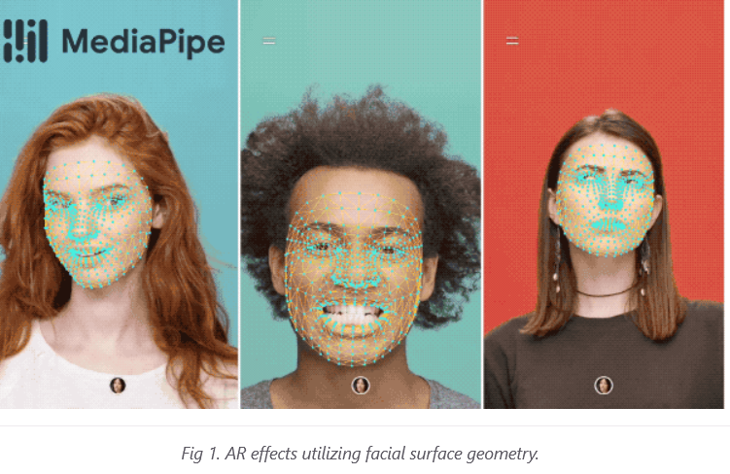

A key “selling” point (it’s free) of Mediapipe is that the code is written in C++, but it can easily be deployed to any platform, from web assembly to Android to MacOS.

When it first released, Mediapipe had only a few demos, but now their GitHub page boasts lots of different demos from persistent object tracking, AR hair coloring, to pose tracking.

**2.5 TensorFlow**



TensorFlow is an end-to-end open source platform for machine learning. It has a comprehensive, flexible ecosystem of tools, libraries, and community resources that lets researchers push the state-of-the-art in ML and developers easily build and deploy ML-powered applications.

TensorFlow was originally developed by researchers and engineers working on the Google Brain team within Google's Machine Intelligence Research organization to conduct machine learning and deep neural networks research. The system is general enough to be applicable in a wide variety of other domains, as well.

TensorFlow provides stable Python and C++ APIs, as well as non-guaranteed backward compatible API for other languages.

**2.6 Keras**

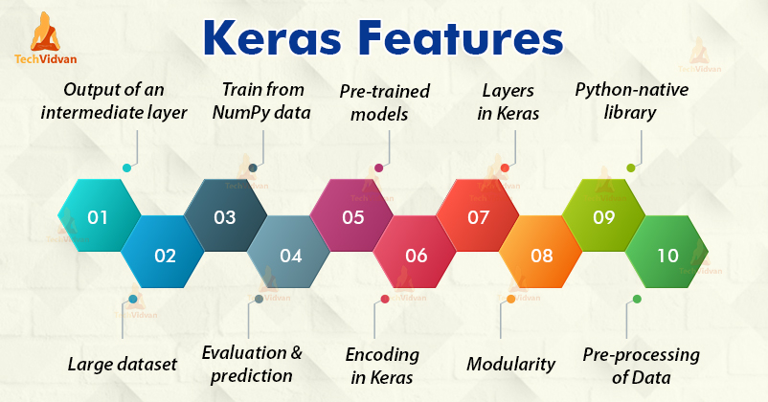

Keras is a deep learning API written in Python, running on top of the machine learning platform TensorFlow. It was developed with a focus on enabling fast experimentation. Being able to go from idea to result as fast as possible is key to doing good research.

Keras is:

* **Simple** -- but not simplistic. Keras reduces developer cognitive load to free you to focus on the parts of the problem that really matter.
* **Flexible** -- Keras adopts the principle of progressive disclosure of complexity: simple workflows should be quick and easy, while arbitrarily advanced workflows should be possible via a clear path that builds upon what you've already learned.
* **Powerful** -- Keras provides industry-strength performance and scalability: it is used by organizations and companies including NASA, YouTube, or Waymo.

**2.7 Google Cloud Text-to-Speech (GTTS)**

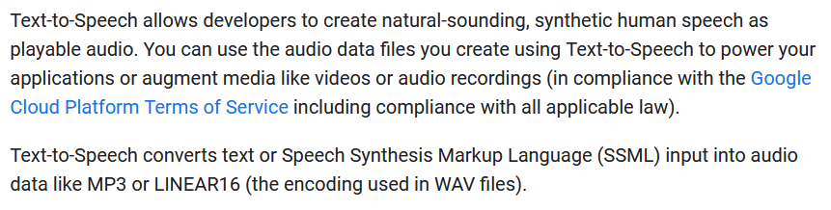

**2.8 Pygame**



**Pygame** is a set of Python modules designed for writing video games. Pygame adds functionality on top of the excellent SDL library. This allows you to create fully featured games and multimedia programs in the python language.

Pygame is highly portable and runs on nearly every platform and operating system.

Pygame itself has been downloaded millions of times.

Pygame is free. Released under the LGPL licence, you can create open source, freeware, shareware, and commercial games with it. See the licence for full details.

For a nice introduction to pygame, examine the line-by-line chimp tutorial, and the introduction for python programmers. buffer, and many other different backends... including an ASCII art backend! OpenGL is often broken on Linux systems, and also on windows systems - which is why professional games use multiple backends.

**Multi core CPUs can be used easily**. --- With dual core CPUs common, and 8 core CPUs cheaply available on desktop systems, making use of multi core CPUs allows you to do more in your game. Selected pygame functions release the dreaded python GIL, which is something you can do from C code.

**Uses optimized C and Assembly code for core functions**. --- C code is often 10-20 times faster than python code, and assembly code can easily be 100x or more times faster than python code.

**Comes with many operating systems**. --- Just an apt-get, emerge, pkg_add, or yast install away. No need to mess with installing it outside of your operating system's package manager. Comes with binary pos system installers (and uninstallers) for Windows or MacOS. Pygame does not require setup tools with even ctypes to install.

**Truly portable**. --- Supports Linux (pygame comes with most mainstream Linux distributions), Windows (95, 98, ME, 2000, XP, Vista, 64-bit Windows, etc), Windows CE, BeOS, MacOS, Mac OS X, FreeBSD, NetBSD, OpenBSD, BSD/OS, Solaris, IRIX, and QNX. The code contains support for AmigaOS, Dreamcast, Atari, AIX, OSF/Tru64, RISC OS, SymbianOS and OS/2, but these are not officially supported. You can use it on handheld devices, game consoles and the One Laptop Per Child (OLPC) computer.

**It's Simple** and easy to use. --- Kids and adults make shooter games with pygame. Pygame is used in the OLPC project and has been taught in essay courses to young kids and college students. It's also used by people who first programmed in z80 assembler or c64 basic.

**Many games have been published**. --- Including Indie Game Festival finalists, Australian Game festival finalists, popular shareware, multimedia projects and open source games. Over 660 projects have been published on the pygame websites such as: list needed. Many more games have been released with SDL (which pygame is based on), so you can be sure much of it has been tested well by millions of users.

**You control your main loop**. --- You call pygame functions, they don't call your functions. This gives you greater control when using other libraries, and for different types of programs.

**Does not require a GUI to use all functions**. --- You can use pygame from a command line if you want to use it just to process images, get joystick input, or play sounds.

**Fast response to reported bugs**. --- Some bugs are patched within an hour of being reported. Do a search on our mailing list for BUG... you'll see for yourself. Sometimes we suck at bug fixes, but mostly we're pretty good bug fixers. Bug reports are quite rare these days, since a lot of them have been fixed already.

**Small amount of code**. --- It does not have hundreds of thousands of lines of code for things you won't use anyway. The core is kept simple, and extra things like GUI libraries, and effects are developed separately outside of pygame.

And last but not least, it is 🡪

**Modular**. --- You can use pieces of pygame separately.   
  
Want to use a different sound library? That's fine. Many of the core modules can be initialized and used separately.  
In fact, this is what we made use of in our project. Its audio control functionality (a sort of side effect) allowed us to play the sounds of speech in MP3 format that GTTS converted from text.

**2.9 PyQt5**



Qt is set of cross-platform C++ libraries that implement high-level APIs for accessing many aspects of modern desktop and mobile systems. These include location and positioning services, multimedia, NFC and Bluetooth connectivity, a Chromium based web browser, as well as traditional UI development.

PyQt5 is a comprehensive set of Python bindings for Qt v5. It is implemented as more than 35 extension modules and enables Python to be used as an alternative application development language to C++ on all supported platforms including iOS and Android.

PyQt5 may also be embedded in C++ based applications to allow users of those applications to configure or enhance the functionality of those applications.

This is what we used to create the GUI for our desktop app.

**3. Problem Statement**  
Speech impaired people use hand signs and gestures to communicate.  
They face difficulty in communicating with other people.  
There is a need for a system which recognizes the different signs, gestures etc. of various SLs and conveys it to everybody in an easy-to-understand manner.

It bridges the gap between SL users & the rest of human society.

**4. Our Approach**  
  
We explored a variety of approaches taken by students & researchers around the world before choosing this route.  
  
🡪 Investigating sign-language recognition through unsupervised feature learning.   
Being able to recognize sign language is an interesting computer vision problem while simultaneously being extremely useful for deaf people to interact with people who don’t know how to understand American Sign Language (ASL).   
  
We got started by creating a data set showing the different hand gestures of the ASL alphabet that we wished to classify.

To more easily approach the problem and obtain reasonable results, we experimented with just up to 5 different classes/letters in our self-made dataset instead of all 26 possible letters as of now.

We tracked the various diff. hand gestures & then captured them through the webcam utilizing MediaPipe -- Google's open-source framework & OpenCV. We used GTTS to convert the text into speech. Pygame to play the audio files. PyQt5 to create the GUI for the desktop app we’ve made so far.

We also plan to make use of TensorFlow & Keras in the future to introduce & refine a deep learning model.

The desktop app is what we’ve started with. But we don’t plan to stick with it for much longer -- beyond early stage development. We’ll be shifting to a cross-platform web-app in the near future.

We also plan to create a temp. GitHub pages website (now) showcasing our work before ***eventually*** setting up a proper website with apt domain name & hosting as we get closer to project completion & launch period.

The website will be developed by us from scratch of course -- both the front & back ends.

**5. Code**

**app.py**

|  |
| --- |
| import os |
|  |

|  |
| --- |
| import sys |
|  |

|  |
| --- |
| import time |
|  |

|  |
| --- |
| import playsound |
|  |

|  |
| --- |
| import subprocess as sp |
|  |

|  |
| --- |
|  |
|  |

|  |
| --- |
| # Spawn the Sign Language Recognition Module |
|  |

|  |
| --- |
| sp.Popen(["py", "SignLanguage_new.py"], shell=True) |
|  |

|  |
| --- |
|  |
|  |

|  |
| --- |
| from gtts import gTTS |
|  |

|  |
| --- |
|  |
|  |

|  |
| --- |
| # cd to Working Directory |
|  |

|  |
| --- |
| cur_dir = os.path.dirname(os.path.realpath(__file__)) |
|  |

|  |
| --- |
| os.chdir(cur_dir) |
|  |

|  |
| --- |
|  |
|  |

|  |
| --- |
| from PyQt5.QtWidgets import ( |
|  |

|  |
| --- |
| QApplication, |
|  |

|  |
| --- |
| QWidget, |
|  |

|  |
| --- |
| QLabel, |
|  |

|  |
| --- |
| QPushButton, |
|  |

|  |
| --- |
| QSlider, |
|  |

|  |
| --- |
| QFileDialog, |
|  |

|  |
| --- |
| QStyle, |
|  |

|  |
| --- |
| QStyleOptionSlider, |
|  |

|  |
| --- |
| ) |
|  |

|  |
| --- |
|  |
|  |

|  |
| --- |
| from PyQt5.QtGui import ( |
|  |

|  |
| --- |
| QIcon, |
|  |

|  |
| --- |
| QPixmap |
|  |

|  |
| --- |
| ) |
|  |

|  |
| --- |
|  |
|  |

|  |
| --- |
| from PyQt5.QtCore import ( |
|  |

|  |
| --- |
| pyqtSlot, |
|  |

|  |
| --- |
| QTimer, |
|  |

|  |
| --- |
| QSize, |
|  |

|  |
| --- |
| QRect, |
|  |

|  |
| --- |
| Qt |
|  |

|  |
| --- |
| ) |
|  |

|  |
| --- |
|  |
|  |

|  |
| --- |
| with open("styles/slider_style.qss") as file: |
|  |

|  |
| --- |
| seekslider_stylesheet = file.read() |
|  |

|  |
| --- |
|  |
|  |

|  |
| --- |
| class functions: |
|  |

|  |
| --- |
| def Speak(mytext): |
|  |

|  |
| --- |
| global speechSoundFile |
|  |

|  |
| --- |
| speechSoundFile = 'temp' |
|  |

|  |
| --- |
| language = 'en-US' |
|  |

|  |
| --- |
|  |
|  |

|  |
| --- |
| if os.path.exists(os.path.join(os.path.dirname(__file__), speechSoundFile+'.mp3')): |
|  |

|  |
| --- |
| os.remove(os.path.join(os.path.dirname(__file__), speechSoundFile+'.mp3')) |
|  |

|  |
| --- |
| myobj = gTTS(text=mytext, lang=language, slow=False) |
|  |

|  |
| --- |
| myobj.save(speechSoundFile+".mp3") |
|  |

|  |
| --- |
|  |
|  |

|  |
| --- |
| print(os.path.join(os.path.dirname(__file__), speechSoundFile+'.mp3')) |
|  |

|  |
| --- |
| playsound.playsound(os.path.join(os.path.dirname(__file__), speechSoundFile+'.mp3')) |
|  |

|  |
| --- |
|  |
|  |

|  |
| --- |
| class App(QWidget): |
|  |

|  |
| --- |
| def __init__(self): |
|  |

|  |
| --- |
| super().__init__() |
|  |

|  |
| --- |
| self.title = "s1gnia" |
|  |

|  |
| --- |
| self.left = 10 |
|  |

|  |
| --- |
| self.top = 100 |
|  |

|  |
| --- |
| self.width = 320 |
|  |

|  |
| --- |
| self.height = 200 |
|  |

|  |
| --- |
|  |
|  |

|  |
| --- |
| self.initUI() |
|  |

|  |
| --- |
|  |
|  |

|  |
| --- |
| self.letter_display = QLabel(self) |
|  |

|  |
| --- |
| self.letter_display.setText("") |
|  |

|  |
| --- |
| self.letter_display.setStyleSheet("color: white; font-size: 50px;") |
|  |

|  |
| --- |
|  |
|  |

|  |
| --- |
| self.setWindowIcon(QIcon("resources/icons/master.svg")) |
|  |

|  |
| --- |
| self.setStyleSheet( |
|  |

|  |
| --- |
| # background-image: url(:resources/images/master_bg.jpg); |
|  |

|  |
| --- |
| """ |
|  |

|  |
| --- |
| background: #212121; |
|  |

|  |
| --- |
| border: none; |
|  |

|  |
| --- |
| """ |
|  |

|  |
| --- |
| ) |
|  |

|  |
| --- |
|  |
|  |

|  |
| --- |
| self.letterUpdate() |
|  |

|  |
| --- |
|  |
|  |

|  |
| --- |
| self.show() |
|  |

|  |
| --- |
|  |
|  |

|  |
| --- |
| def letterRead(self): |
|  |

|  |
| --- |
| with open('letter', 'r', encoding='utf-8') as fp: |
|  |

|  |
| --- |
| return fp.read().strip() |
|  |

|  |
| --- |
|  |
|  |

|  |
| --- |
| def letterUpdate(self): |
|  |

|  |
| --- |
| self.letter_display.setText(self.letterRead().lower()) |
|  |

|  |
| --- |
|  |
|  |

|  |
| --- |
| self.timer = QTimer() |
|  |

|  |
| --- |
| self.timer.setSingleShot(True) |
|  |

|  |
| --- |
| self.timer.timeout.connect(self.letterUpdate) |
|  |

|  |
| --- |
| self.timer.start(1000) |
|  |

|  |
| --- |
|  |
|  |

|  |
| --- |
| def initUI(self): |
|  |

|  |
| --- |
| self.setWindowTitle(self.title) |
|  |

|  |
| --- |
| self.setGeometry(self.left, self.top, self.width, self.height) |
|  |

|  |
| --- |
|  |
|  |

|  |
| --- |
| # self.button = QPushButton("", self) |
|  |

|  |
| --- |
| # self.button.setToolTip("Toggle Play/Pause") |
|  |

|  |
| --- |
| # self.button.move(110, 70) |
|  |

|  |
| --- |
| # self.button.clicked.connect(self.letterUpdate) |
|  |

|  |
| --- |
|  |
|  |

|  |
| --- |
| # self.button.setIcon(QIcon(rf"D:\OneDrive - Suncity School\My Stuff\-COMPUTERS-\My Py Files\SIGN-LANG-MUJ-HACK-6.0\AI Volume Control\venv\Lib\site-packages\matplotlib\mpl-data\images\home.svg")) |
|  |

|  |
| --- |
| # self.button.setIconSize(QSize(40, 40)) |
|  |

|  |
| --- |
| # # self.button.setStyleSheet(f'background-image: url(resources/Layouts/{Layout}/MediaControls/play.svg);') |
|  |

|  |
| --- |
| # self.button.resize(200, 200) |
|  |

|  |
| --- |
|  |
|  |

|  |
| --- |
|  |
|  |

|  |
| --- |
| if __name__ == "__main__": |
|  |

|  |
| --- |
| # --- Start App --- # |
|  |

|  |
| --- |
| app = QApplication(sys.argv) |
|  |

|  |
| --- |
| ex = App() |
|  |

|  |
| --- |
| app.exec_() |
|  |

|  |
| --- |
|  |
|  |

# multi()

**https://github.com/Vivojay/muj-hacks-6.0-Reveilon**

**6. Experimental Results and Discussions**

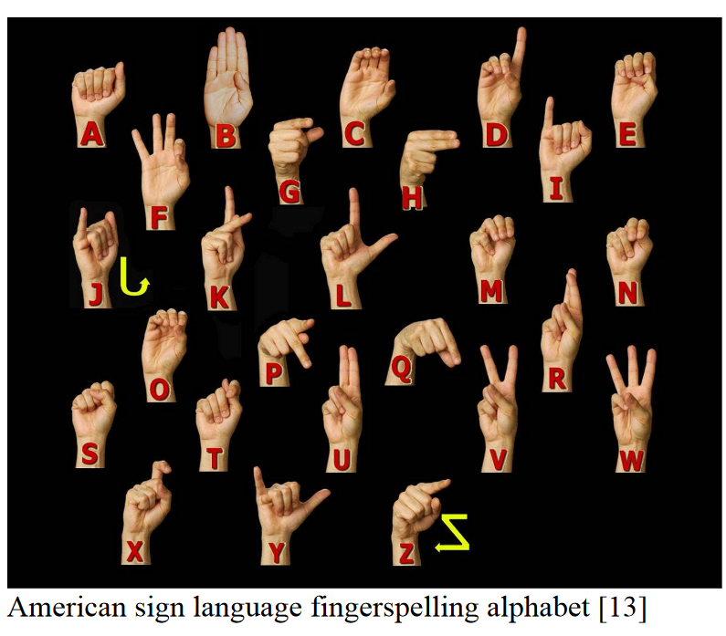 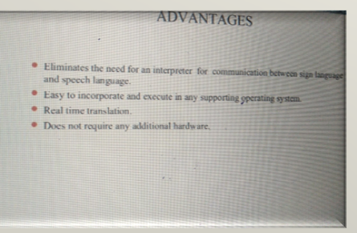

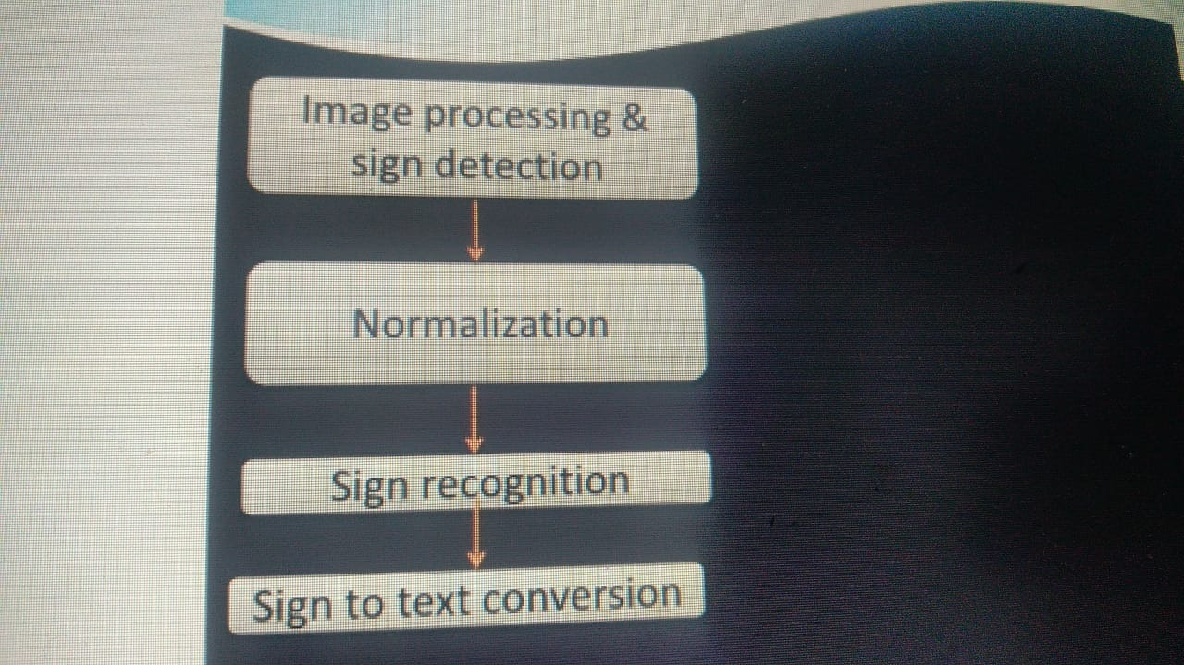

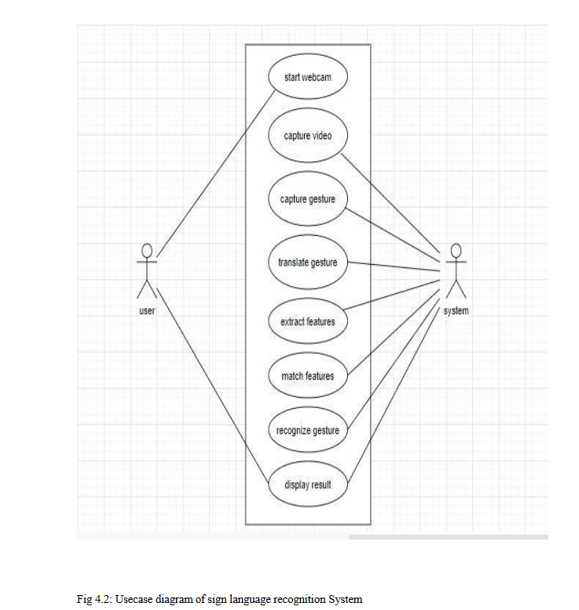

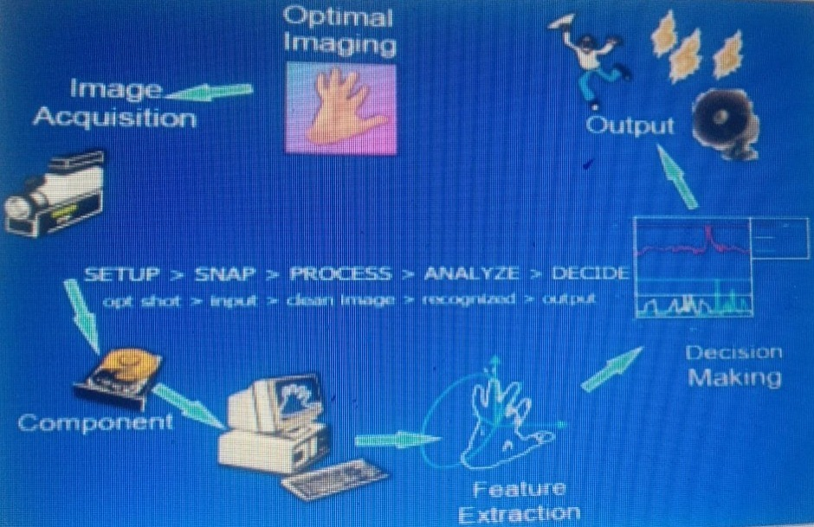

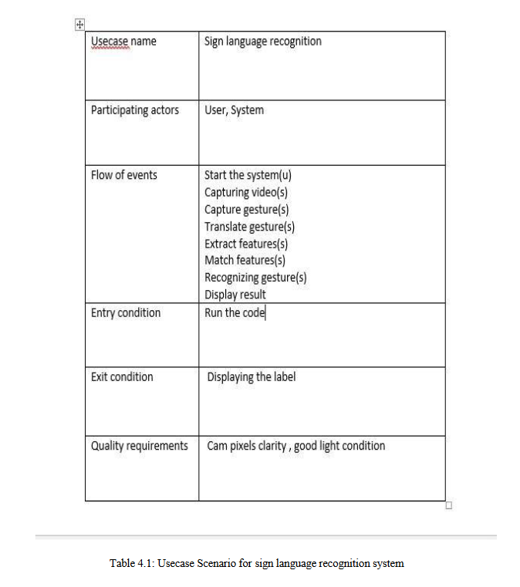

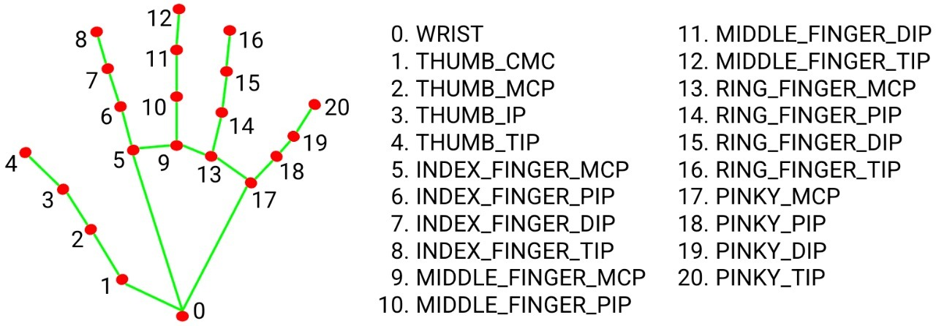

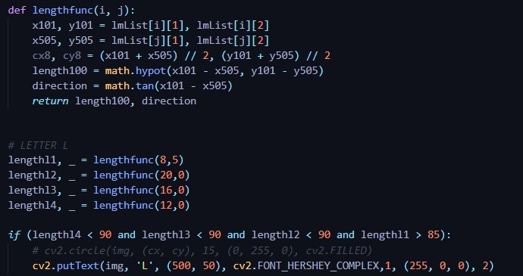

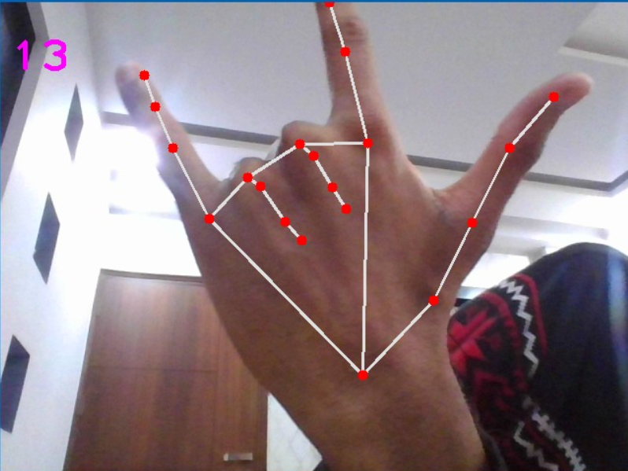 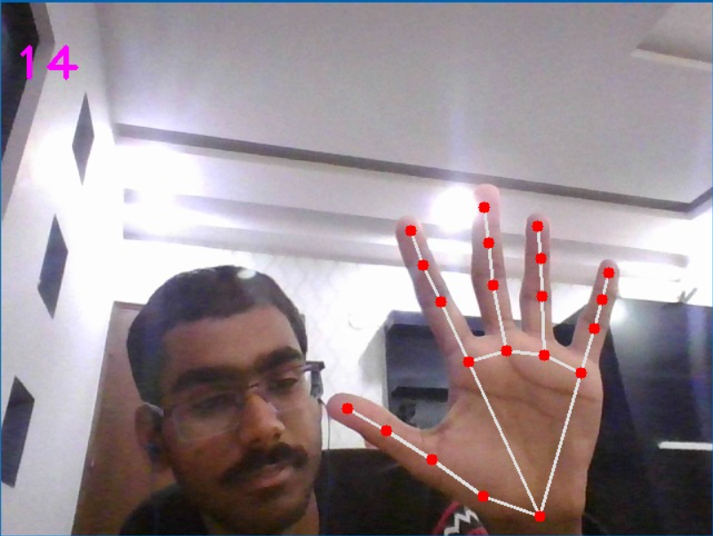

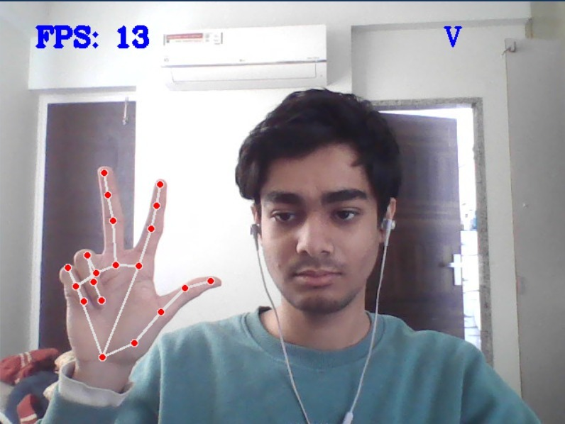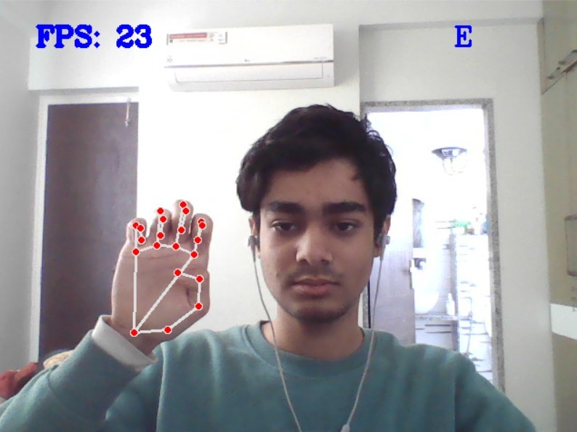

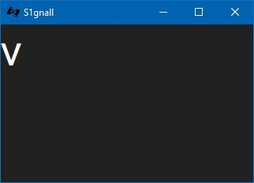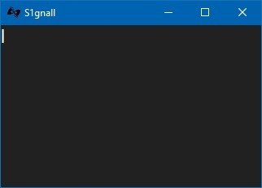

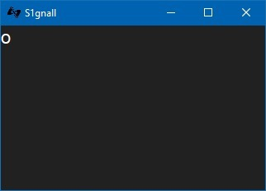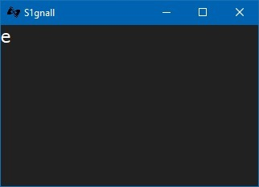

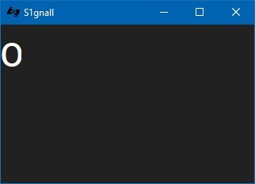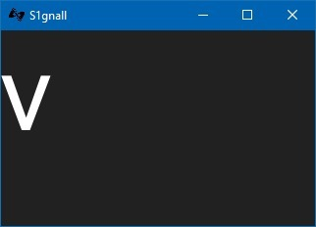

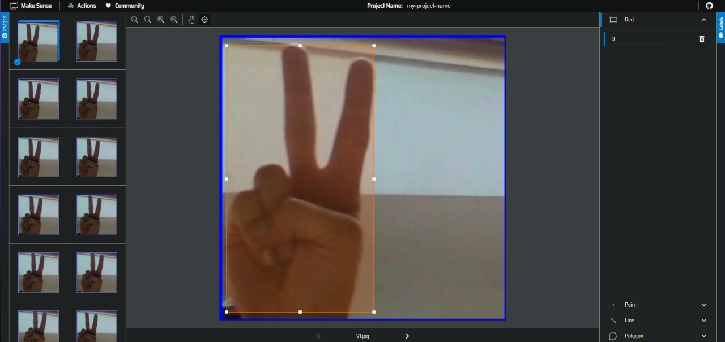

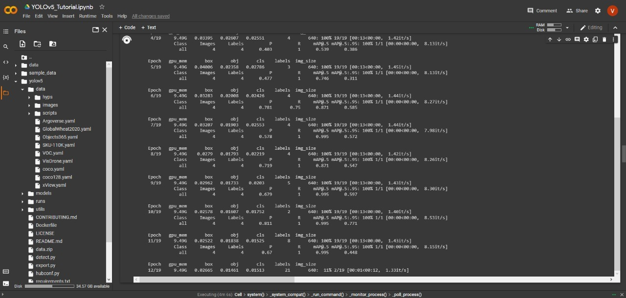

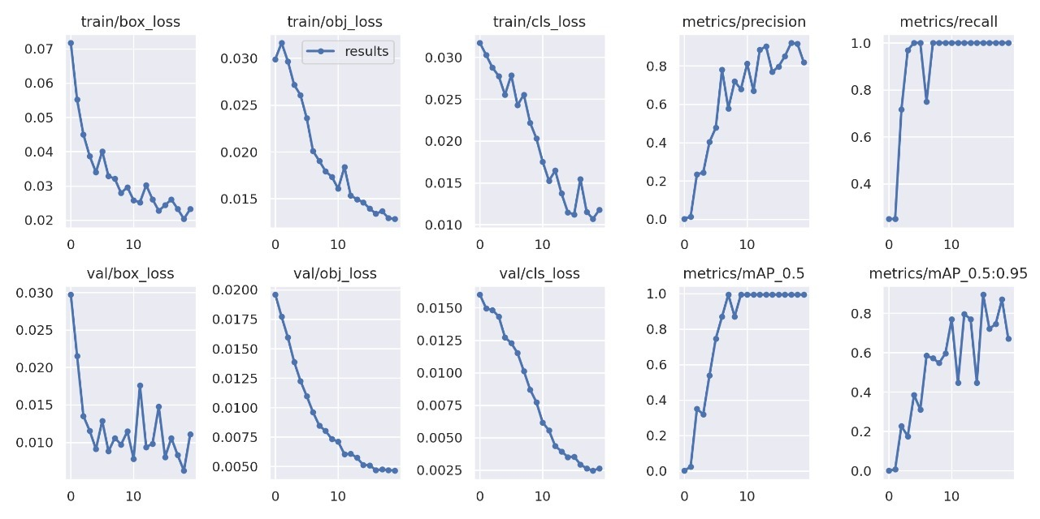

**7. Conclusion and Future Possibilities**In this project, we have implemented an automatic sign language gesture recognition system in real time, using tools learnt in computer vision and machine learning.  
  
We learned about how sometimes basic approaches work better than complicated approaches.   
  
We also realized the time constraints and difficulties of creating a dataset from scratch. Looking back, it would have been nice to have had a dataset already to work off of.   
  
Some letters were harder to classify such as ”a” vs ”i” since they only differ by a very small edge (the ”i” has the pinky pointing up).   
  
There’s still a lot of work to be done.

We also plan to make use of TensorFlow & Keras in the future to introduce & refine a deep learning model.

The desktop app is what we’ve started with. But we don’t plan to stick with it for much longer -- beyond early stage development. We’ll be shifting to a cross-platform web-app in the near future.

We also plan to create a temp. GitHub pages website (now) showcasing our work before ***eventually*** setting up a proper website with apt domain name & hosting as we get closer to project completion & launch period.

The website will be developed by us from scratch of course -- both the front & back ends.

Upon completion of our goals there is still much room for further development. 🡪  
  
Possible extensions to this project would be extending the gesture recognition system to all alphabets of the ASL and other non-alphabet gestures as well.   
  
We could also probably improve the speed of our real-time system by coding it in C.   
The framework of this project can also be extended to several other applications like controlling robot navigation using hand gestures etc.

**8. Business Model/Strategies & Timeline**

* Application software for deaf and dumb people.
* Model for teaching and medical use

How? 🡪   
  
Collaboration with WHO, rehabilitation centres and medical organizations (NAD) etc. across the world.

**B2B structure**

Aim for government funding/collaboration and working with regional incubation centres.

Subscription model for mobile application (Android & iOS), desktop setup with free demo – monthly subscription, premium tier with added functionality.

Working with NGOs in India, China, the Middle-East, African nations, the EU

* Social Networks and Viral Marketing.
* Paid Media Advertising.
* Internet Marketing.
* Email Marketing.
* Direct Selling.
* Point-of-Purchase (POP) Marketing.
* Co-Branding, Affinity, and Cause Marketing.
* Conversational Marketing
* Event management and sponsorship

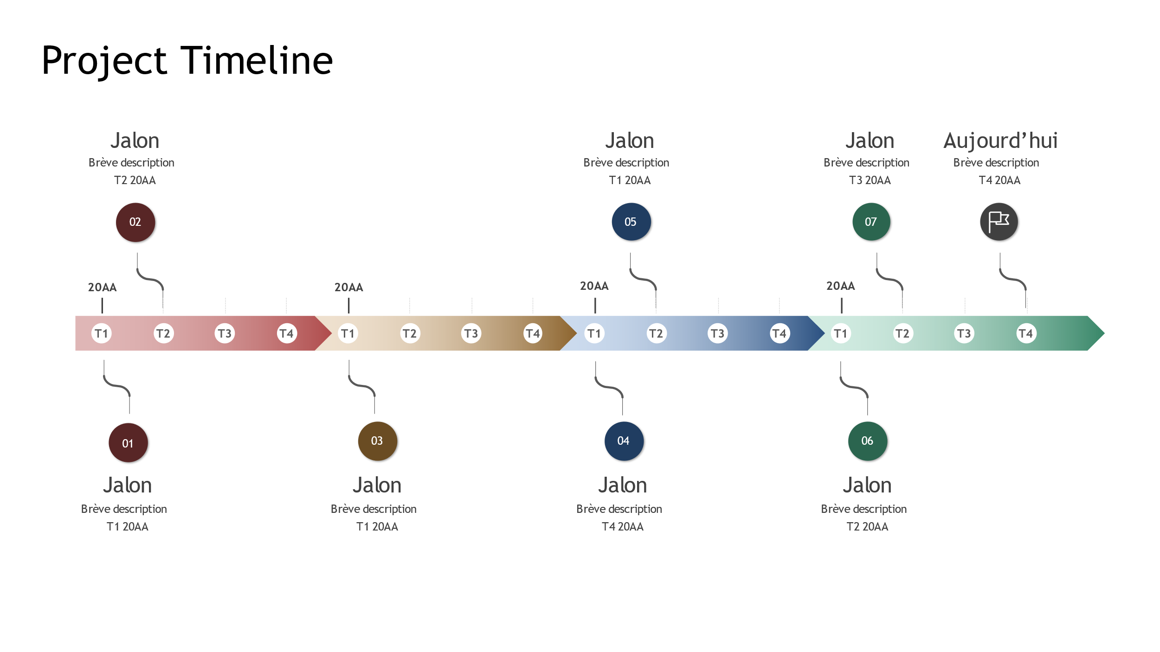

**9. References**

1. Mitchell, Ross; Young, Travas; Bachleda, Bellamie; Karchmer, Michael (2006). "How Many People Use ASL in the United States?: Why Estimates Need Updating" (PDF) Sign Language Studies (Gallaudet University Press).
2. J. Atwood, M. Eicholtz, and J. Farrell. American Sign Language Recognition System. Artificial Intelligence and Machine Learning for Engineering Design. Dept. of Mechanical Engineering, Carnegie Mellon University, 2012
3. Lifeprint.com. American Sign Language (ASL) Manual Alphabet (fingerspelling) 2007
4. Davis, J and Shas M., Gesture Recognition, Technical Report CS-TR-93-11,University  
   of Central Florida, 1993
5. J Kramer and L Leifer. The Talking Glove: A Speaking Aid for Nonvocal Deaf and  
   Deaf-Blind Individuals, Proc. of the RESNA 12th annual Conf. (1993) pp. 471-472
6. M. D. Skowronski and J.G. Harris, Automatic speech recognition using a predictive echo  
   state network classifier, Neural Networks, Volume 20, Issue 3, pp:414-423, April 2007.
7. Peter Wray Vamplew , PhD Thesis: Recognition of Sign Language Using Neural Net-  
   works, Flinders University of South Australia, 1990
8. Philippe Drew, Research on Sign Language Recognition: http://www-  
   i6.informatik.rwth-aachen.de/∼dreuw/database.php
9. Philippe Drew, David Rybach, Thomas Deselaers, Morteza Zahedi, Herman Ney, Speech  
   recognition techniques for sign language recognition system, In Interspeech, pages 2513-  
   2516, Antwerp, Belgium, August 2007.
10. R. Rojas, Neural Networks: A Systematic Introduction, Springer, 1996.
11. S. Sidney Fels and Geo rey E. Hinton, Glove-TalkII: A neural network interface which  
    maps gestures to parallel formant speech synthesizer controls, Transactions on Neural  
    Networks, 9 (1), 205–212. 1998.
12. Tom M. Mitchell, Machine Learning, McGraw-Hill, 1997
13. Vladimir Vezhnevets, Vassili Sazonov, Alla Andreeva, A Survey on Pixel-Based Skin  
    Color Detection Techniques, Graphics and Media Laboratory, Faculty of Computational  
    Mathematics and Cybernetics, Moscow State University, 2002.
14. Wilhelm Burger, Mark J. Burge, Digital Image Processing - An Algorithmic Introduction  
    using Java, Springer-Verlag Berlin, Heidelberg, New York, 2008.
15. Lungociu, Corneliu. Real time sign language recognition using artificial neural networks. Studia Univ. Babes ̧–Bolyai, Informatica, Volume LVI, Number 4, 2011
16. D Prakhya, D Krishna Vamsi, M Sri Manjari, A Varaprasadh, NSV Krishna Reddy. A robust sign language and hand gesture recognition system using convolution neural networks, Department of Computer Science and Engineering, Anil Neerukonda Institute of Technology & Sciences, A.P., India
17. http://cs231n.stanford.edu/reports/2016/pdfs/214_Report.pdf
18. http://www.iosrjen.org/Papers/vol3_issue2%20(part-2)/H03224551.pdf
19. https://adeshpande3.github.io/adeshpande3.github.io/A-Beginner's-Guide-To-  
    Understanding-Convolutional-Neural-Networks
20. Press CU. Cambridge Dictionary. [Online]. Available from: http://dictionary.cambridge.org/dictionary/english/deaf.
21. Press CU. Cambridge Dictionary. [Online]. Available from: http://dictionary.cambridge.org/dictionary/english/mute.
22. Wang H, Chai X, Zhou Y, Chen X. Fast sign language recognition benefited from low rank approximation. 2015 11th IEEE International Conference and Workshops on Automatic Face and Gesture Recognition, FG 2015. 2015.
23. Singha J, Das K. Indian Sign Language Recognition Using Eigen Value Weighted Euclidean Distance Based Classification Technique. arXiv preprint arXiv:1303.0634. 2013: p. 188-195.
24. Kalsh EA, Garewal NS. Sign Language Recognition System. International Journal of Computational Engineering Research. 2013: p. 15-21.
25. Tewari D, Srivastava S. A Visual Recognition of Static Hand Gestures in Indian Sign Language based on Kohonen Self-Organizing Map Algorithm. International Journal of Engineering and Advanced Technology (IJEAT). 2012: p. 165-170.
26. Raheja JL, Mishra A, Chaudary A. Indian Sign Language Recognition Using SVM 1. Pattern Recognition and Image Analysis. 2016 September
27. Kishore PVV, Prasad MVD, Prasad CR, Rahul R. 4-Camera model for sign language recognition using elliptical Fourier descriptors and ANN. In International Conference on Signal Processing and Communication Engineering Systems - Proceedings of SPACES 2015, in Association with IEEE; 2015. p. 34-38.
28. Goyal, Sakshi & Sharma, Ishita & Sharma, Shanu. Sign Language Recognition System For Deaf And Dumb People. International Journal of Engineering Research & Technology (IJERT). 2013 April.
29. Huang J, Zhou W, Li H, Li W. Sign language recognition using 3D convolutional neural networks. In Multimedia and Expo (ICME), 2015 IEEE International Conference on; 2015: IEEE. p. 1-6.
30. Chai X, Li G, Lin Y, Xu Z, Tang Y, Chen X. Sign Language Recognition and Translation with Kinect. The 10th IEEE International Conference on Automatic Face and Gesture Recognition. 2013;: p. 22-26.
31. Pigou L, Dieleman S, Kindermans PJ, Schrauwen B. Sign Language Recognition using Convolutional Neural Networks. In Workshop at the European Conference on Computer Vision; 2014; Belgium. p. 572-578.
32. Greg C. Lee & Fu-Hao Yeh & Yi-Han Hsiao. Kinect-based Taiwanese sign-language recognition system. Multimed Tools Appl. 2014 October.
33. Zhang LG, Chen Y, Fang G, Chen X, Gao W. A Vision-Based Sign Language Recognition System. In Proceedings of the 6th International Conference on Multimodal Interfaces; 2004; Pennsylvania: ACM. p. 198-204.
34. Lokhande P. Data Gloves for Sign Language Recognition System. International Journal of Computer Applications. 2015;: p. 11-14.
35. Gao W, Fang G, Zhao D, Chen Y. A Chinese sign language recognition system based on SOFM/SRN/HMM. Pattern Recognition. 2004 Ap ril: p. 2389-2402.
36. Thang PQ, Dung ND, Thuy NT. A Comparison of SimpSVM and RVM for Sign Language Recognition. Proceedings of the 2017 International Conference on Machine Learning and Soft Computing - ICMLSC '17. 2017: p. 98-104.
37. Li Y, Chen X, Zhang X, Wang K, Wang ZJ. A sign-component-based framework for Chinese sign language recognition using accelerometer and sEMG data. IEEE Transactions on Biomedical Engineering. 2012: p. 2695-2704.
38. Mohandes M, Aliyu S, Deriche M. Arabic sign language recognition using the leap motion controller. In Industrial Electronics (ISIE), 2014 IEEE 23rd International Symposium on; 2014; Dhahran. p. 960-965.
39. DBJ. Leap Motion Controller and Touchless Technology - Dartmouth Business Journal. [Online].; 2013 [cited 2017 August 15. Available from: http://dartmouthbusinessjournal.com/2013/08/23/the-leap-motion-controller-and-touchless-technology/.
40. Krizhevsky A, Skutskever I, Hinton GE. ImageNet Classification with Deep Convolutional Neural Networks. Advances In Neural Information Processing Systems. 2012;: p. 1-9.
41. Koller O, Zargaran O, Ney H, Bowden R. Deep Sign: Hybrid CNN-HMM for Continuous Sign Language Recognition. In Proceedings of the British Machine Vision Conference 2016; 2016.
42. Goyal, ER. Kanika & Singh, Amitoj. Indian Sign Language Recognition System for Deaf People. Journal on Today's Ideas - Tomorrow's Technologies. 2014 December.
43. Goyal, Sakshi & Sharma, Ishita & Sharma, Shanu. Sign Language Recognition System for Deaf and Dumb People. International Journal of Engineering Research and Technology. 2013 April.
44. Gurjal, P., & Kunnur, K. Real Time Hand Gesture Recognition Using SIFT. International Journal of Electrics and Electrical. 2012
45. Suharjitoa, Ricky Andersonb, Fanny Wiryanab, Meita Chandra Ariestab, Gede Putra  
    Kusumaa. Sign Language Recognition Application Systems for Deaf-Mute People: A Review Based on Input-Process-Output. 2nd International Conference on Computer Science and Computational Intelligence 2017, ICCSCI, 2017, 13-14 October 2017, Bali, Indonesia.
46. D. Metaxas. Sign language and human activity recognition, June 2011. CVPR Workshop on Gesture Recognition
47. Justin Chen. CS231A Course Project Final Report. Sign Language Recognition with Unsupervised Feature Learning. Stanford University
48. https://en.wikipedia.org/wiki/Sign_language
49. https://uxdesign.cc/a-quick-checklist-for-hackathon-idea-presentation-2053b781ee24
50. https://templates.office.com/en-ca/milestone-and-history-timeline-tm16411194
51. https://www.flaticon.com/search?word=sign%20language&type=icon